Project Design Phase-II
Data Flow Diagram & User Stories

Date | 02 July 2026
Team ID
Project Name | Sports Hall Booking System using Service Portal (ServiceNow)
Maximum Marks | 4 Marks

Data Flow Diagrams:
In a sports hall booking system, a DFD acts as a functional blueprint. It does not look at database triggers, code loops, or UI design. Instead, it tracks the lifecycle of an asset lease—how a physical space (a court) is requested, validated, paid for, locked against double-booking, and released.

Example: (Simplified)
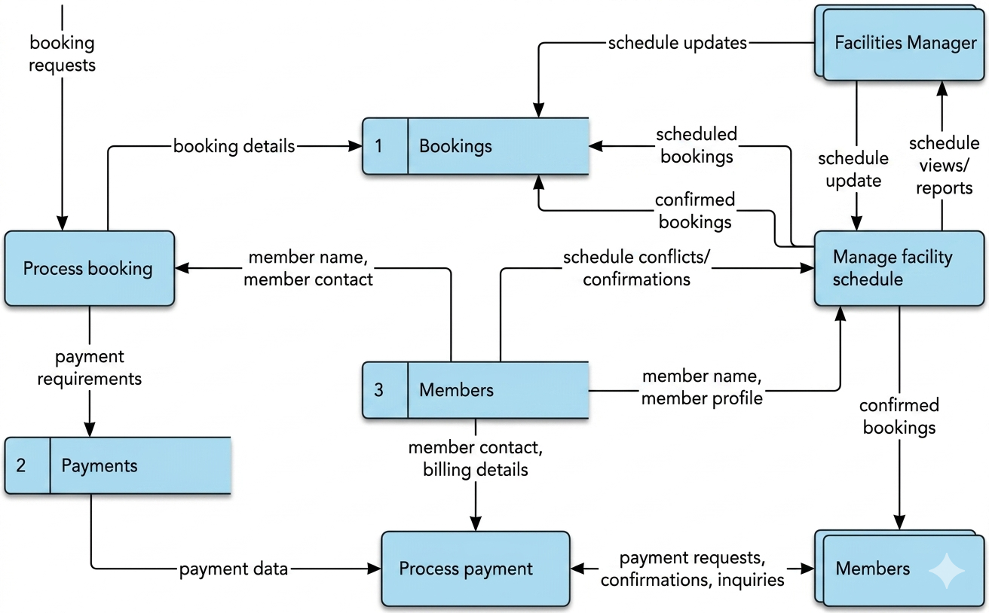

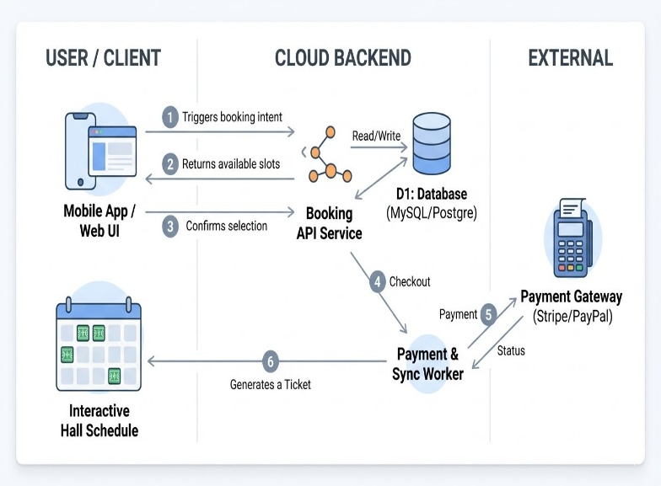
User Stories
Use the below template to list all the user stories for the product.
User Type | Functional Requirement (Epic) | User Story Number | User Story / Task | Acceptance criteria | Priority | Release
Customer | Account Management | USN-1 | As a new athlete/user, I want to create an account using my email and phone number so that I can track my bookings. | Form validates email format & valid phone number.  • Password requires 8+ characters, 1 number, 1 symbol.  • Redirects to dashboard upon success. | High | Sprint-1
Customer | Account Management | USN-2 | As a user, I want to log in using biometrics (FaceID/TouchID) or password so I can access the app quickly. | Biometrics toggle option available in settings.  • Falling back to password login works seamlessly.  • System locks account for 15 mins after 5 failed attempts. | Medium | Sprint-1
Customer | Court Discovery | USN-3 | As a user, I can register for the application through Facebook | I can register & access the dashboard with Facebook Login | Low | Sprint-2
Customer | Booking Engine | USN-4 | As a user, I can register for the application through Gmail | Visual countdown timer shown on screen.  • Slot releases automatically if timer hits 0:00.  • Prevents other users from selecting the same slot during hold. | High | Sprint-1
Customer | Booking Engine | USN-5 | As a recurring player, I want to reserve a court on a weekly repeating schedule for a fixed duration (e.g., every Tuesday for 6 weeks). | Bulk booking discount applied automatically if applicable.  • Checks for schedule conflicts across all 6 weeks before payment.  • Generates a master reference number with sub-tickets. | Low | Sprint-2

